+91 7777766666



1 77777 66666



SHIRISH KUMAR

shirish@gmail.com



www.linkedin.com/in/shirish



SOFTWARE ENGINEER

Phagwara, Punjab



[Shirish](https://sdgjekxzr/)



SUMMARY

TECHNICAL SKILLS

Programming languages: Java, Javascript, NodeJS, C++ Web Technologies:

Rest, J2EE, HTML5, CSS

Data Modelling:

XML, XSLT

Data Management:

MySQL, MongoDB, MS Access Platforms:

Unix, MS Windows98, 2000, XP, Vista,

Window7

CERTIFICATIONS

Soft Skills Marathon Course | The Open University | Dec '20 Java Standard Edition Programmer | Oracle Certified Associate | Nov '19

POWER SKILLS

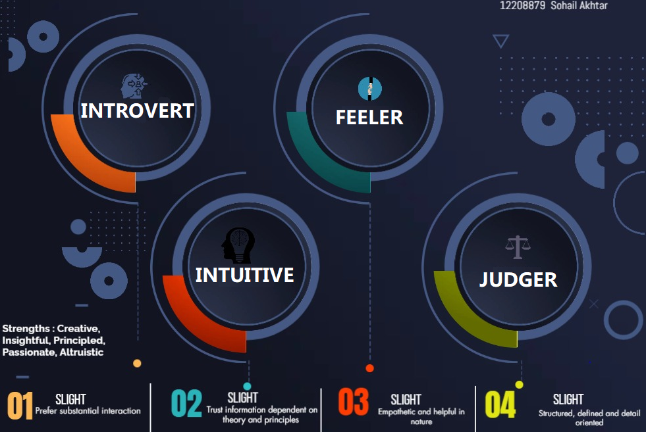

EXTRA CURRICULAR ACTIVITIES

A Competition on Digital Presentation Feb'23 Memories to Talk- An Event on Public Speaking Skills Dec'21

INTERNSHIP

Software Engineering Intern Sep '22 - Nov '22 Multi Learn Technologies | Jaipur, IN

Application Development & Software Testing

Gained hands-on experience in developing, implementing, and maintaining internal web applications

Assisted the technical and business staff with the design, development, testing, implementation, and maintenance of new programs using-NodeJS on a weekly basis Performed automated and manual tests to ensure the software created by developers is up to date and working seamlessly

Detected and tracked software bugs and inconsistencies in the program

PROJECTS

Hotel Management System Aug'22

Domain: Web Application|Programming Languages: Swift, Javascript, C++ Constructed an application to reserve hotel rooms for a specific location Developed features for the application and created a new landing page to enhance customer experience

Utilized Swift to create a new template to automatically price-compare

Memory Game Feb'22

Domain: JavaScript | Programming Languages: HTML, CSS, Java | Built a memory game using C++ and Javascript to test IQ

Upgraded code to make the game error-free

Created HTML, CSS, JavaScript, and JSP pages for user interaction

ACHIEVEMENTS

Aptmania- A Competition on Problem-Solving Jan '22 - Mar '22 Secured 1st position in the competition which showcased analytical and problem- solving skills

4 Star Rating in Java on HackerRank Feb '21 - Apr '21

EDUCATION

B.Tech. in Computer Science Apr '20 - Present Lovely Professional University | Phagwara, IN

CGPA 7.75

Higher Secondary Jun '19 - Mar '20

ABC High School | Phagwara, IN CGPA 8.8